Detection of Cognitive Impairment with eye tracking using Deep Learning Techniques

SCREENING TOOL FOR DETECTION OF DEMENTIA USING EYE TRACKER TECHNOLOGY

Nishitha U, Revanth Kandimalla, Mourya Vardhan Reddy M, Jyotsna C, Tripty Singh , Dept. of Computer Science & Engineering, Amrita School of Computing, Bengaluru,

Amrita Vishwa Vidyapeetham, India [unishitha9@gmail.com,](mailto:unishitha9@gmail.com) [revu5974@gmail.com,](mailto:revu5974@gmail.com) [mourya0410@gmail.com,](mailto:mourya0410@gmail.com)

[c_jyotsna@blr.amrita.edu,](mailto:c_jyotsna@blr.amrita.edu)[tripty_singh@blr.amrita.du](mailto:tripty_singh@blr.amrita.du)

***Abstract*—Long ago, it was very difficult to observe the disease of dementia by only consulting a geriatrician. Nowadays the cases of this disease are growing rapidly from generation to generation. After knowing that people were affected with this disease that used to cost more money and time for the cure. So, to prevent this and make people aware of this disease eye tracking technology is used to detect by monitoring in real-time. Using this tracker makes it easy to analyze the stage at which the disease is in if it is present. We propose a model for the detection of cognitive impairment by observing the movement of the human eye using a Trail Making Test. The data taken from the various persons consist of features like error rate, fixation duration, saccade duration, total fixation, saccade count, and many more. The proposed model makes use of many machine learning and deep learning techniques to get various inferences on cognitive impairment and is classified into three different stages.**

***Keywords—Dementia, Cognitive Impairment, Trail Making Test, Saccade, Fixation.***

1. **INTRODUCTION**

One of the most common conditional characteristic situations which are very common around the world is Dementia which is caused by the impairment of two brain functions causing conditions like memory loss and similar situations, which makes it difficult for us to carry out daily tasks. A psychological experiment of visual recognition is called the Trail Making Test.

The test’s objective is to spot cognitive decline brought on by Dementia and can let us know more about the cognitive abilities of a person.

The test is to spot/track the gestures made by the eye of the person known as eye tracking. An eye tracker tool for monitoring eye moments and positions. This technology is used in product design, marketing, human-computer interaction (HCI), psychology, psycholinguistics, and visual system research. There are several ways to measure eye movement. The most often used variations extract the moment of the eye from video pictures other techniques rely on the electrooculogram or search coils.

There are multiple movements that an eye makes such as Fixation duration, saccade duration, number of blinks, and eye pupil diameter, which helps us to detect dementia using this technology.

Fixation refers to the time that the eye pauses to gather visual information and the distance between two fixations that the eye make is called saccades.

The location and motion of the eye are tracked using an eye tracker. i.e. the cornea begins to reflect and the reflection is captured by an infrared camera which will also outline the

pupil’s focus, infer eyeball rotation, and identify the location of the glance.

1. **LITERATURE SURVEY**

In this paper, we use a trial-making test technique to identify dementia. Eye tracking technology can be used to gather precise data on eye movements and gaze patterns, which can then be analyzed using machine learning and deep learning algorithms to identify patterns and anomalies that may indicate cognitive impairment [1].

In general, with their capacity to learn complicated properties directly from the input data, CNNs have demonstrated significant promise in the assessment of cognitive impairment using eye-tracking data. [1] This makes them an effective tool for precise and individualized diagnosis and treatment.

When subjects are engaged in a specific task and their eyes are fixed on a screen, eye movement tracking technology can record their eye gaze and compare it to that of healthy people to determine whether they have Cognitive impairment. Other parameters that can be compared include the amount of time spent looking at the same pictures, rotational speed, distance, etc. [2]. Because it is a state indication rather than a biological signal, the altered eye movement trajectory in patients with cognitive impairment is independent of the modest local movements.

Machine learning algorithms can be trained to recognize particular eye movement patterns that are connected to cognitive disorders like Alzheimer's disease or attention deficit hyperactivity disorder (ADHD). Large amounts of eye-tracking data can be analyzed using deep learning techniques to spot minor variations in gaze patterns over time that can be used to spot cognitive deterioration or changes in cognitive function [3].

The assessment and treatment of cognitive impairment using eye-tracking data have the potential to be considerably improved by deep learning. [3] Deep learning algorithms can recognize patterns in eye-tracking data that might not be visible to human observers by using artificial neural networks. This helps to increase the precision and speed of diagnosis as well as the effectiveness of individualized treatment.

Many other authors used either the machine learning models or the deep learning models but this paper focuses on hybrid models which have machine learning models embedded in

deep learning models. And the dataset used by the models in this paper is not used before as it was derived using an eye- tracker and the features were extracted from the coordinates of the eye-tracker.

1. **METHODOLOGY**

The workflow diagram initially consists of data collection and preprocessing of the collected dataset and then we split the datasets into training and validation sets and then we defined its neural network later we compiled and trained the model and then it was ready for the testing process. As per the motive of our project, the model that can be built follows this workflow:

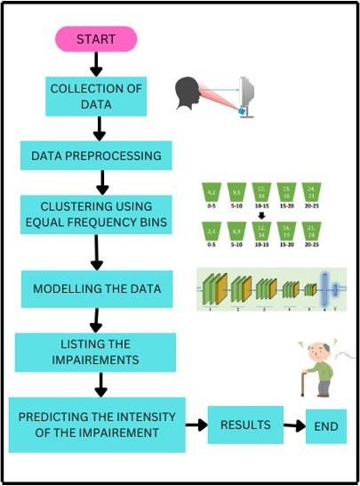

Fig (1). Workflow of the proposed model.

* 1. *Data Description:*

The data which is been collected is in the form of an Excel sheet using an eye tracker, with various features like Time, Left Pupil Diameter (mm), Left Pupil Pos X, Left Pupil Pos Y, Right Calibrated, Right Pupil Diameter (mm), Right Pupil Pos X, Right Pupil Pos Y, Image Width, Image Height, Right Gaze Point X (% Display Width), Image Height, Image Scale Factor, we now have 4 datasets naming TMT_A1, TMT_B1, TMT_A2, TMT_B2, each indicate different images to check the cognitive impairment of a human. Using these features, we are going the fixation coordinates and saccade coordinates, etc. Using these fixations and saccade we can easily plot the graphs to see how the user is viewing the image. As we can see below the sample of the dataset from the eye tracker.

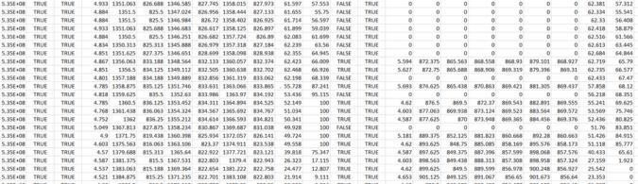

Fig (2). Data collected from eye-tracker

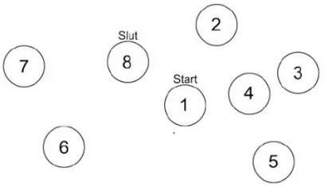

Fig (2). TMT_A1 sample

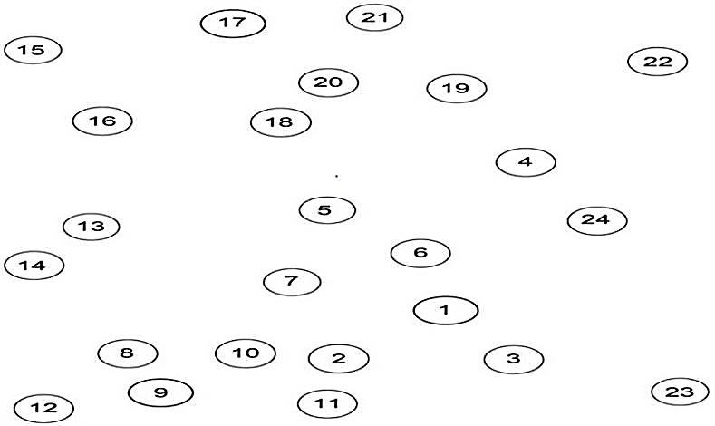

Fig (3). TMT_A2 sample

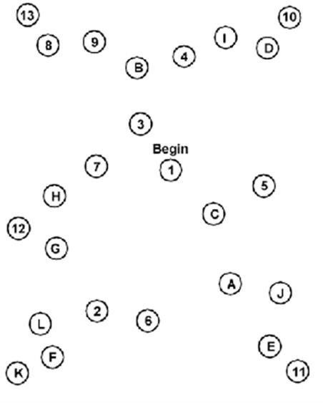

Fig (4). TMT_B1 sample

* 1. *Data Preprocessing:*

The eye tracker only gives the data in x and y coordinates and from these coordinates the fixations, saccade, latency error rate, etc., are found. A subset of data preprocessing which happens in Pre – Processing stage, refers to any transformation done on original data to prepare it for the next data analysis process. Data cleaning is a process of data preprocessing where irrelevant and inconsistent data is identified and removed.

* 1. *Feature Extraction:*

As the data collected from the eye tracker has only the x And y coordinates of the eye which moved according to the image shown through the eye tracker. From those coordinates many features were extracted as shown below:

* + 1. *Saccade detection:*

Saccades are fast, brief motions of the eyes that occur once the target of fixation are suddenly changed. Movements might be very little, like some of those made when scanning, or very large, as all those produced during searching a space. To locate the movements, use this code. It's described as a string of observations when the velocity profile or momentum between them exceeds a certain value. It takes X and Y coordinates from the data and time to track its timestamps as its arguments and gives Ssac which means lists of lists with each congaing start time and Esac which is a list of lists with start time, end time, duration etc. as its output.

The important features extracted after saccade detection are average left and right eye saccade duration, left and right eye diameter, left and right eye velocity and their minimum and maximum velocity.

* + 1. *Fixation detection:*

Fixation detection is to find the fixation movements to simulate a change in gaze estimations within the scene camera-defined frame of reference of the eye tracker. Our technique takes use of the fact that, regardless of user or gaze target mobility, target appearance is rather constant throughout a fixation. In order to identify fixations, it pulls visual data from small areas near the current gaze point and compares how these gaze patches appear over video frames.

By using fixation detection, the features extracted are average of left eye fixation duration and right eye fixation duration, fixation time, left eye amplitude, right eye amplitude, minimum and maximum amplitude.

* + 1. *Blink detection:*

This is a feature which is extracted based on how many times each person had blinked their eye while the eye tracker is recording the data for the displayed image. If a person is suffering from dementia, that person cannot see something for too long without blinking eye. So, if a person blinks eyes for many times then it is considered as that person may be affected with dementia.

Blink can be detected by the coordinates of the eye which were marked as zeros for some period of time as they are not watching anything at that time. From the blink detection, features extracted are left eye blink, right eye blink, blink duration and total blink count.

* + 1. *MMSE score:*

The Mini-Mental State Examination (MMSE) is the

most popular and widely used brief screening test for giving an overall view of cognitive impairment in medical, academic, and community - based settings.

There is a cutoff of 30 on the MMSE. The range of reasonable is 0 to 25, with 25 being the normal. Cognitive impairment may be suspected if a person's result would be less than 24. Your performance on the test is evaluated by how quickly you complete each section. Higher results suggest a more severe level of cognitive impairment. Even though the test is highly helpful, older persons may perform less accurately, and the test's accuracy varies depending on the condition being assessed.

The TMT scores may provide light on two areas:

The "average" score on these tests is what's used to characterize mental capacity. When the score rises, it indicates mental decline. The patient's mental abilities are likely still present if the findings are less. Marks over a certain threshold may indicate cognitive deficits. If a human's result drops below that threshold, they are considered to have "deficient" skills.

* 1. *Modelling the Data: MLP Network Architecture:*

Multi-Layer Perceptron Network has fully dense layers which allow transforming input dimensions to any desired dimensions. MLP can deal with both linear and non-linear separable data. The data which is given as input will be passed to many hidden layers present to get the desired output. Each hidden layer consists of weights and an activation function. The input layer has 10 neurons, corresponding to the 10 features in our dataset. The first dense layer has 64 neurons and uses the ReLU activation function. The second dense layer has 32 neurons and also uses the ReLU activation function. Finally, the output layer has a single neuron with a sigmoid activation function. This architecture is a common example of a fully connected dense neural network. The ReLU activation function is used in the hidden layers to introduce nonlinearity and the sigmoid activation function is used in the output layer for binary classification. The diagram can also help to identify any issues with the model architecture such as the presence of redundant layers, input/output shape mismatches, or any other issues that may be hindering the model's performance.

*CNN network architecture:*

CNN is a special type of neural network main idea behind CNN is using filters are sliding windows by which we can find patterns and similarities and features image has edges and shapes and filters are responsible to detect these features of the image first layer in CNN gives edges and this is passed to further layer and next layer gives some features.

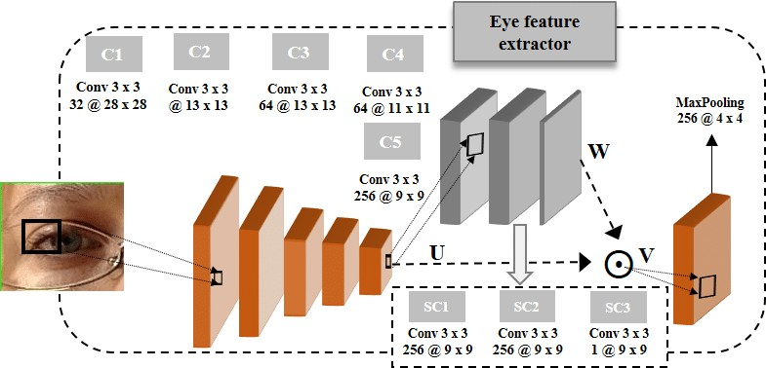

Fig (5) CNN architecture for cognitive impairment

Three layers make up the model architecture: a 1D convolutional layer with 64 filters and a kernel size of 2, then a max pooling layer with a pool size of 2 to lessen the output's dimensionality. A fully connected layer with 32 units and a ReLU activation function is then fed the flattened, resultant feature maps. A single sigmoid activation function-equipped unit in the output layer generates a binary output. Accuracy measurements are tracked during training on a model that uses the Adam optimizer and Mean Squared Error loss function.

*Regularization:*

Regularization is technique that is used to help avoid overfitting and increase the accuracy of the deep learning

model when we give a whole new dataset from the problem domain. They also help in improving the generalization ability. The techniques that helped us avoid overfitting for our CNN model are 1] L1/L2 Dropout

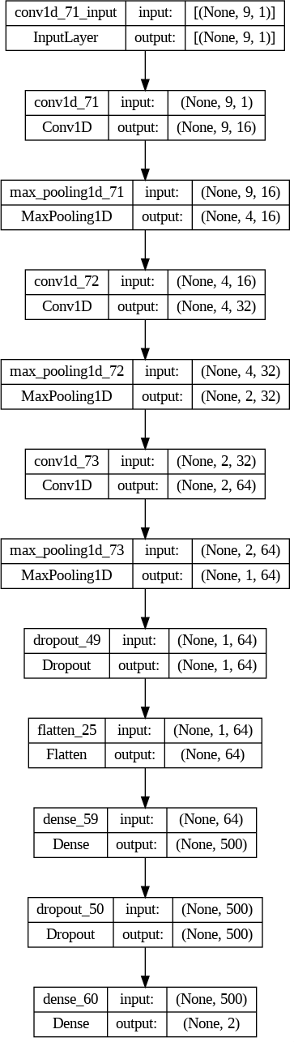

Fig (6). Model build for Regularization.

L1 is Lasso regression and L2 is Ridge regression where L1 regularization adds a squared magnitude of coefficient as penalty term to the loss function and L2 regularization adds the absolute value of the magnitude of coefficient as penalty term to the loss function. In Dropout regularization, it randomly selects and removes some nodes of the neural network along with their incoming connections and outgoing connections.

*Optimization:*

The optimization algorithm’s performance directly influences the training efficiency of the model. Optimization helps deep learning by lowering the loss function. Optimization is a process in which we adjust the parameters of a neural network to minimize a loss function during the training of the model. The architecture above is convolutional neural network (CNN). Different layers of CNN and their purpose:

* + 1. Convolutional Layers:

The model starts with a 1Dimensional convolutional layer with 16 filters, a kernel size of 2, and padding. This layer is responsible for capturing features in the input sequence.

Two more convolutional layers are added with increasing filter sizes of 32 and 64, respectively. these layers capture more complex patterns.

* + 1. Max Pooling Layers:

After each convolutional layer, a max pooling layer with a pool size of 2 is added. This layer reduces the spatial dimensions of the feature maps and extracts the most important information.

* + 1. Dropout Layers:

Dropout is a regularization technique used to avoid overfitting in neural networks. In this model, a dropout layer with a rate of 0.2 is added after the last max pooling layer and after the first dense layer. It randomly sets a fraction of input units to 0 during training, which helps to reduce overfitting and introducing noise and by this model also learns more robust features

* + 1. Flatten Layer:

The feature maps produced by the convolutional layers are then flattened into a 1D vector. This allows the output to be fed into the dense layers of the network.

* + 1. Dense Layers:

After flattening, a dense layer with 500 units and ReLU activation is added. This layer help to learn complex combinations of features from input. Another dropout layer with a rate of 0.2 is applied to the output of the previous dense layer. Finally, the output layer consists of a dense layer with 2 neurons and a SoftMax activation function. SoftMax ensures that the predicted class probabilities sum up to 1.

* + 1. Compilation:

The model is compiled with the Adam optimizer, which is a popular optimization algorithm for training neural networks. The loss function is set to mean squared error .However, this may not be efficient for a classification task. You may consider using Binary cross-entropy or Binary categorical cross-entropy, depending on the nature of your problem.

The model's performance is evaluated using the accuracy metric.

* + 1. Training:

The model is trained on the provided data for 300 epochs. The training data is divided into batches of size 30.

Validation data (X_val and y_val) is used to monitor the model’s performance during training. *Listing the Impairments:*

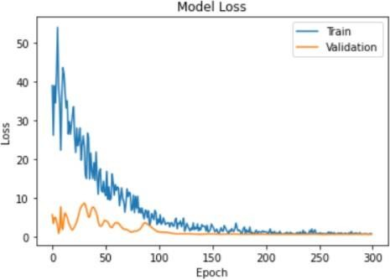

Fig (7). Training and Validation loss graph for MLP Network.

The plot was made using the MLP model with the training loss (in blue) and validation loss (in orange) on the y-axis and the number of epochs on the x-axis. You can use this plot to check if the network is overfitting (training loss is low, but validation loss is high) or underfitting (both training and validation loss are high). A regular fit should have both the training and validation loss decreasing and converging to a low value. As observed from the above image there is a lot of fluctuation in the training and the validation losses with an accuracy of 35% and testing loss being 70% which causes a lot of variations compared to the required results.

Test Accuracy: 35%

Test loss: 70%

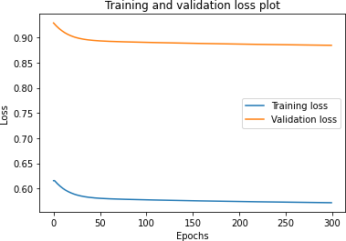

Fig (8). Training and Validation loss graph for CNN Network.

But as we can see over here by using the CNN classifier the graph has been changed i.e. the graph is more normalized and the fluctuations are highly reduced compared to the previous graph they are more stable now and we can see the curves are well more classified and the accuracy turned out to be 65% and the testing loss being 35%.

Test Accuracy: 65%

Test loss: 70%

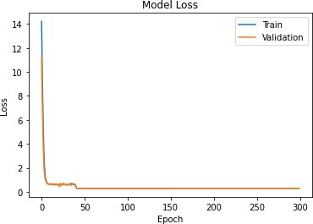

Fig (9). Training and Validation loss graph after regularization.

Before performing the regularization technique, due to overfitting the accuracy of our model was 75 % using Naïve Bayes Classifier. After performing the L1 regularization with dropout and L2 regularization with dropout technique and reducing the overfitting, the accuracy of our CNN model increased to 87.50 % which we can say is quite significant. And after performing the regularization techniques we can observe the normalization of training and validation loss.

* 1. *Predicting the Intensity of Impairment:*

If we are dealing with an image data set then it is very difficult to use MLP because, for example, the colored image has pixels of 1000X1000 then in MLP there are many inputs and the number of hidden layers will be more than the CPU cannot handle.

There can be many neurons and a greater number of weight parameters which may lead to overfitting and also gives wrong predictions these are the limitation of a neural network to overcome this we use CNN. CNNs are often better than MLPs for image and video processing tasks. This is because the convolutional layers in CNNs are specifically designed to detect spatial patterns, which is important for these types of tasks. MLPs can still be effective for image and video processing, but they may require more data and training time to achieve similar performance.

*Classifiers and Accuracies:*

Table(1). Accuracies got after using classifiers.

|  |  |
| --- | --- |
| **Classifier** | **Accuracy** |
| KNN Classifier | 0.45 |
| Decision Tree | 0.5 |
| Random Forest Classifier | 0.5 |
| Naïve Bayas Classifier | 0.75 |

As this is a classification model this has 2 classes cognitive impairment low (0) and high (1). This is a bi-class classification model. Various classifiers are being trained and tested to check the accuracy after the classification of the testing set by training with a training set. As we can observe that Naïve Bayas classifier has more accuracy as compared with many other classifiers. Naïve Bayes classifier usually performs well for bi-classification.

*Naïve Bayas Classifier:*

Naive Bayes is the classifier that uses probability in which presence of features in class doesn’t depend on presence of other features. It’s used for spam mail filtering, text analysis. Naive Bayes calculates the probability of each class from set of features and based on their probabilities selects the class which has the higher probability as the predicted class. It is more efficient.

*Regression and accuracies:*

Table(2). Accuracies got after using regressors.

|  |  |
| --- | --- |
| **Regressors** | **Accuracy** |
| Liner Regression | 0.53 |
| Random Forest regressor | 0.28 |
| ADA Boosted Tree regressor | 0.27 |
| Gradient Boosted Tree regression | 0.37 |
| XG Boosting regressor | 0.38 |

As this is a classification model, the accuracies got by using different regressors are very low. But the accuracy got by using linear regression is quite good after training the model and testing with the testing set.

*Regularization and accuracies:*

Table(3). Accuracies got after performing regularization.

|  |  |  |  |  |  |
| --- | --- | --- | --- | --- | --- |
| **Regularizat ion** | **Los s** | **Accura cy** | **Precisi on** | **Reca ll** | **F1-**  **scor e** |
| L1 | 3.60 | 0.2 | 0.235 | 0.57  1 | 0.33 |
| L2 | 1.09  3 | 0.25 | 0.25 | 0.57  1 | 0.34  8 |
| Dropout | 0.69  3 | 0.35 | 1.00 | 1.00 | 1.00 |
| Early stop | 0.83  1 | 0.695 | 0.44 | 0.85  71 | 0.5 |
| Data augmentation with L1  and dropout | 0.28 | 0.35 | 0.43 | 0.57 | 0.38 |
| Data augmentation with L2 and dropout | 0.25 | 0.65 | 0.44 | 0.67 | 0.64 |

As the high precision and recall make few false positive predictions and false negative predictions by that there will be the correct classification of class after the prediction using the testing set. By regularization we can prevent overfitting and underfitting of the model and the model complexity will be grown to build a good classification model. It is observed that by using dropout only it is undergoing overfitting which will lead to the wrong classification of data. Whereas for early stop it is observed that the accuracy is more, and the predictions are made quite well without undergoing any underfitting or overfitting.

*Optimization and accuracies:*

Table(4). Accuracies got after using optimization.

|  |  |  |  |  |
| --- | --- | --- | --- | --- |
| **Optimizer** | **Test Loss** | **Test Accuracy** | **Val Loss** | **Val Accuracy** |
| Adadelta | 0.698 | 0.35 | 0.65 | 0.87 |
| Adagrad | 0.691 | 0.35 | 0.68 | 0.87 |
| Adam | 0.705 | 0.35 | 0.5 | 0.87 |
| RMSprop | 0.692 | 0.65 | 0.69 | 0.87 |
| SGD | 0.708 | 0.35 | 0.65 | 0.87 |

*SGD optimization:*

Stochastic Gradient Descent is an important optimization technique that is widely used in deep learning. Here in SGD, a few samples are selected at random for each iteration instead of selecting and iterating the whole dataset. It is a variant of the gradient descent algorithm used for the optimization of machine learning models.

*ADAM optimization:*

Adaptive moment estimation is one of the popular and widely used optimization algorithms used in deep learning which is an extension of stochastic gradient descent. Numerous neural network architectures and data formats are compatible with this optimization method. It is a combination of two other optimization methods, Adagrad and RMSprop.

1. **DISCUSSION**

Many machine learning and Deep learning models have been used in this paper on the data set for better results. Deep learning is a subset of machine learning which can be used and would be efficient over large datasets and deep learning models are more reliable towards the new data added to datasets when compared to machine learning models. Since the data used is highly dimensional and has a large number of features and image processing is done for eye tracking, deep learning models are used. Many hybrid models have been used in this paper which means many of the deep learning models that we used have machine learning models embedded in them and that is the major difference from other papers which are published by other authors.

1. **CONCLUSION**

Cognitive impairment has become a severe problem nowadays and it is recognized too late by the people who were affected by this disease. But many other models were built by many others to detect dementia disease and grade the level of cognitive impairment. But there was a lot of wrong predictions were done by the machine learning models as they were unable to handle larger datasets and real-time data got by the eye tracker. Deep learning models worked quite well and they were able to handle, pre-process the data, and classify the patients as high and low classes. The patients who were classified as high needed to refer the doctors as soon as possible. By using the Naïve-Bayes classifier for the classification of data, Early stop for regularization, and ADAM as an optimizer we obtained an accuracy of 85% after testing it with the dataset. A better model by using other regularization and optimization techniques will predict more accurately and can be tried for future use with more accuracy.

1. **REFERENCES**
2. Tao, L., Wang, Q., Liu, D. et al. Eye tracking metrics to screen and assess cognitive impairment in patients with neurological disorders. Neurol Sci 41, 1697–1704 (2020). https://doi.org/10.1007/s10072-020-04310-y
3. Liu Z, Yang Z, Gu Y, Liu H, Wang P (2021) The effectiveness of eye tracking in the diagnosis of cognitive disorders: A systematic review and meta-analysis. PLoS ONE 16(7): e0254059. https://doi.org/10.1371/journal.pone.0254059
4. W. Liu, J. Zhang and Y. Zhao, "A Comparison of Deep Learning and Traditional Machine Learning Approaches in Detecting Cognitive Impairment Using MRI Scans," 2022 IEEE 46th Annual Computers, Software, and Applications Conference (COMPSAC), Los Alamitos, CA, USA, 2022, pp. 998-1001, doi: 10.1109/COMPSAC54236.2022.00154.
5. R. U. Haque, A. L. Pongos, C. M. Manzanares, J. J. Lah, A. I. Levey and G. D. Clifford, "Deep Convolutional Neural Networks and Transfer Learning for Measuring Cognitive Impairment Using Eye- Tracking in a Distributed Tablet-Based Environment," in IEEE Transactions on Biomedical Engineering, vol. 68, no. 1, pp. 11-18, Jan. 2021, doi: 10.1109/TBME.2020.2990734.J. Clerk Maxwell, A Treatise on Electricity and Magnetism, 3rd ed., vol. 2. Oxford: Clarendon, 1892, pp.68–73.
6. Ahmad F. Klaib, Nawaf O. Alsrehin, Wasen Y. Melhem, Haneen O. Bashtawi, Aws A. Magableh, Eye tracking algorithms, techniques, tools, and applications with an emphasis on machine learning and Internet of Things technologies, Expert Systems with Applications, Volume 166, 2021, 114037, ISSN 0957-4174.
7. K. Mengoudi et al., "Augmenting Dementia Cognitive Assessment With Instruction-Less Eye-Tracking Tests," in IEEE Journal of Biomedical and Health Informatics, vol. 24, no. 11, pp. 3066-3075, Nov. 2020, doi: 10.1109/JBHI.2020.3004686.
8. Nerušil, B., Polec, J., Škunda, J. et al. Eye tracking based dyslexia detection using a holistic approach. Sci Rep 11, 15687 (2021).
9. Kathleen C. Fraser, Kristina Lundholm Fors, Dimitrios Kokkinakis, and Arto Nordlund. 2017. An analysis of eye-movements during reading for the detection of mild cognitive impairment. In Proceedings of the 2017 Conference on Empirical Methods in Natural Language Processing, pages 1016–1026, Copenhagen, Denmark. Association for Computational Linguistics.
10. D. Greco, F. Masulli, S. Rovetta, A. Cabri and D. Daffonchio, "A Cost- Effective Eye-Tracker for Early Detection of Mild Cognitive Impairment," 2022 IEEE 21st Mediterranean Electrotechnical Conference (MELECON), Palermo, Italy, 2022, pp. 1141-1146, doi: 10.1109/MELECON53508.2022.9843008.
11. Kaczorowska, M.; Plechawska-Wójcik, M.; Tokovarov, M. Interpretable Machine Learning Models for Three-Way Classification of Cognitive Workload Levels for Eye-Tracking Features. Brain Sci. 2021, 11, 210.
12. Zhongjun Lin, Yinghua Liu, Hui Wang, Zhengji Liu, Sijin Cai, Zhicheng Zheng, Yongjin Zhou, Xinyu Zhang,
13. An eye tracker based on webcam and its preliminary application evaluation in Chinese reading tests, Biomedical Signal Processing and Control, Volume 74, 2022, 103521, ISSN 1746-8094
14. Valentina Bachurina, Svetlana Sushchinskaya, Maxim Sharaev, Evgeny Burnaev, Marie Arsalidou, A machine learning investigation of factors that contribute to predicting cognitive performance:

Difficulty level, reaction time and eye-movements, Decision Support Systems, Volume 155, 2022, 113713, ISSN 0167-9236

1. Wolf Alexandra, Ueda Kazuo,Contribution of Eye-Tracking to Study Cognitive Impairments Among Clinical Populations,Frontiers in Psychology ,volume :12 ,2021
2. Seyedi, S., Jiang, Z., Levey, A. et al. An investigation of privacy preservation in deep learning-based eye-tracking. BioMed Eng OnLine 21, 67 (2022).
3. Pereira, Marta Luísa Gonçalves de Freitas et al. ‘Visual Search Efficiency in Mild Cognitive Impairment and Alzheimer’s Disease: An Eye Movement Study’. 1 Jan. 2020 : 261 – 275
4. S. Tang et al., "Unity Human Eye Model for Gaze Tracking with a Query-Driven Dynamic Vision Sensor," 2022 44th Annual International Conference of the IEEE Engineering in Medicine & Biology Society (EMBC), Glasgow, Scotland, United Kingdom, 2022, pp. 2194-2198, doi: 10.1109/EMBC48229.2022.9871193.
5. Thalia S. Field, Sally May Newton-Mason, Sheetal Shajan, Oswald Barral, Hyeju Jang, Thomas Soroski, Zoe O'Neill, Cristina Conati,

Giuseppe Carenini

1. L. Höglund, ‘Analysis of Eye Tracking Data from Parkinson’s Patients using Machine Learning’, Dissertation, 2021.
2. B. Nerušil, J. Polec and J. Škunda, "Detection of Dyslexia Using Eye Tracking," 2021 Signal Processing Symposium (SPSympo), LODZ, Poland, 2021, pp. 202-205, doi: 10.1109/SPSympo51155.2020.9593313.
3. R. Logeshwari, T. Malathi, R. Thandaiah Prabu, P. Prasath and C.

Rajive Gandhi, <https://doi.org/10.1142/S0219467823400028>

1. He Yanxian, Wu Jun, Zhou Li, Chen Yi, Li Fang, Qian Hongjin,Quantification of Cognitive Function in Alzheimer’s Disease Based on Deep Learning ,Frontiers in Neuroscience ,VOLUME=15,YEAR=2021 ,DOI=10.3389/fnins.2021.651920

,ISSN=1662-453X

1. T. Babu, T. Singh, D. Gupta and S. Hameed, "Colon Cancer Detection in Biopsy Images for Indian Population at Different Magnification Factors Using Texture Features," 2017 Ninth International Conference on Advanced Computing (ICoAC), Chennai, India, 2017, pp. 192-197, doi: 10.1109/ICoAC.2017.8441173.
2. R. Nair, T. Singh and R. Nayar, "Logistic regression for Mouth (orotracheal) or Nose (nasotracheal) endotracheal intubation," 2017 IEEE International Conference on Power, Control, Signals and Instrumentation Engineering (ICPCSI), Chennai, India, 2017, pp. 2026-2031, doi: 10.1109/ICPCSI.2017.8392071.
3. M. S. Mounica, M. Manvita, C. Jyotsna and J. Amudha, "Low Cost Eye Gaze Tracker Using Web Camera," 2019 3rd International Conference on Computing Methodologies and Communication (ICCMC), Erode, India, 2019, pp. 79-85, doi: 10.1109/ICCMC.2019.8819645.
4. D. Venugopal, J. Amudha and C. Jyotsna, "Developing an application 10.1109/RTEICT.2016.7808086.
5. C. Jyotsna and J. Amudha, "Eye Gaze as an Indicator for Stress Level Analysis in Students," 2018 International Conference on Advances in Computing, Communications and Informatics (ICACCI), Bangalore, India, 2018, pp. 1588-1593, doi: 10.1109/ICACCI.2018.8554715.
6. Jyotsna, C. et al. ‘Intelligent Gaze Tracking Approach for Trail Making Test’. 1 Jan. 2020 : 6299 – 6310.
7. ] N. Narmada, V. Shekhar and T. Singh, "Classification of Kidney Ailments using CNN in CT Images," 2022 13th International Conference on Computing Communication and Networking Technologies (ICCCNT), Kharagpur, India, 2022, pp. 1-5, doi:b10.1109/ICCCNT54827.2022.9984256.